- Call to Order
- Deanna Sellnow called to order the faculty meeting of the Department of Communication at 10:00 AM on November 5, 2021 on Zoom.
- Roll Call/Attendance
Deanna Sellnow, Maria Pichardo, Bridget Rubenking, Ann Miller, David Young, Matthew Maddex, Gary LaPage, George Musambria, Harry Weger, James MCafferty, Jamie Vega, Lindsay Neuberger, Jen Sandoval, Jennifer Roth-Miller, Jinyun Kim, Jonathan Conway, Michael Strawser, Nan Yu, Patric Spence, Renata Koldziej-Smith, Rufus Barfield, Tim Sellnow, Regina Franceis, Robb Lauzon, Kim Tuorto, Michelle Dusseau, Steven Neel, Lindsay Haddock, , Shari Hodgson, Christine Hanlon, Adam Parish, Karisa Workman, Jorris Bright, Lakelyn Taylor, Jonathan Matusitz, David Young
- Approval of September 2021 Minutes
- Approved Unanimously
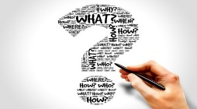
- M.A.D. (Making a Difference)

- Research
Kim, J., Song, H., Merrill Jr. K. Jung, Y., & Kwon, R. J. (2021). If you quit smoking, this could happen to you: Investigating framing and modeling effects in an anti-smoking serious game. International Journal of Human-Computer Interaction. https://doi.org/10.1080/10447318.2021.1970429
- Teaching
  - Regina Francies - Presented a six-hour technical presentations workshop
- September 29 and October 6, for UCF STEM Ambassadors
- Michelle Dusseau –Osceola Library System Staff Development Day Presentation on “Communicative with Complex Personalities”
- Michelle Dusseau – Barbara Ying Center, Inclusion Champions Program. Presented on “Communication in Times of Social Change”
- Denise Lowe received a Quality course designation on 9/23/2021 for COM3801, COM3802, COM4804

- Service & Awards
            - Harry Weger, Lindsay Neuberger, and Jonathan Matusitz were inducted into UCF’s Scroll and Quill Society (Decade of research excellence in publications & articles)

The honorees represent some of UCF’s best and brightest faculty who have helped elevate the university’s reputation on the national and international stages.
https://www.ucf.edu/news/21-faculty-members-inducted-into-ucf-scroll-and-quill-society/

            - Adam Parrish was recognized as Faculty Member of the Game for Women’s Soccer on 9/23/2021
- Renata Kolodziej-Smith was nominated by her students as a Faculty Member of the upcoming game on November 20th
- Michelle Dusseau –Faculty Marshall for COS Graduation Ceremony November 5
- Michelle Dusseau – Newly appointed advisor for the Women’s Student Union and launching a news program called “Afternoon Safe TEA” for women on campus to discuss safety and allyship.
- Rebecca Morales-Magsino First Staff member to be recognized at the UCF South Florida Game Thanksgiving Weekend (11/26/21) for her dedication to student athlete scholars.
- Florida Communication Association October 14-16 (Faculty):
Hodgson, S., Workman, K., (2021 October). Creating student involvement & community in different course modalities. Panel presented at the 91st annual Florida Communication Association conference, virtual. *Won the Top Panel Award*
- Francies, R., Presented as a part of a panel entitled, “A cycle of contagious collaboration during COVID: How UCF STEM students, faculty, staff and community partners carried on during a pandemic” Panel presented at the 91st annual Florida Communication Association conference.
- Hodgson, S., & Workman, K. Presented Panel Workshop, “Creating Student Involvement and Community in Different Course Modalities,” October 2021 Florida Communication Association Convention.
- Hodgson, S., & Workman, K. “Best Panel Presentation Award,” October 2021 Florida Communication Association.
- Workman, K. UCF Admissions and Standards Committee, COS Representative.
- Workman, K. Chair, School Advisory Committee, Hagerty High School.
- Workman, K. Faculty Advisor, Student Organization: Wesley at UCF.

- Student Success
Lakelyn Taylor - Florida Communication Association Acceptances/Awards (Students):
- Lunsford, K., & Freihaut, R. (2021 October). The multiple sclerosis community on Reddit: Convergence, divergence, and sensemaking g. Paper presented at the 91st annual Florida Communication Association conference, virtual.
- Nahhas, R. (2021 October). Why I did not report my sexual assault: A thematic analysis of Instagram #WhyIDidntReport, self-disclosure and stigma. Paper presented at the 91st annual Florida Communication Association conference, virtual.
- Mayer, M., Eicher, R., & Kubota, G. (2021 October). Understanding climate skepticism: Motivation behind climate change doubt and denial. Paper presented at the 91st annual Florida Communication Association conference, virtual. *Won the Top Graduate Student Paper Award*
- Eicher, R. (2021 October). Fight chaos with chaos: Applying chaos theory toward communicating uncertainty in tropical cyclone intensity forecasts. Paper presented at the 91st annual Florida Communication Association conference, virtual.

- Taylor, L. E. (2021 October). It takes two to tango - Analyzing trust and risk perceptions in human vs. machine-modeling hurricane weather reports. Paper presented at the 91st annual Florida Communication Association conference, virtual.
Adam Parrish - NCSM’s First Free Speech Week was a success! More than 800 students attended three events over three days and provided valuable and positive feedback.

Highlight
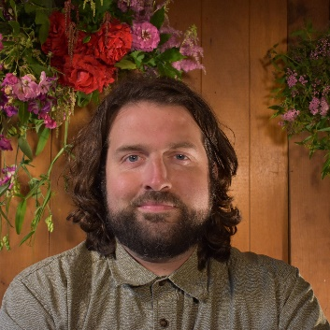
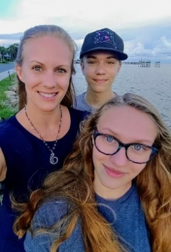
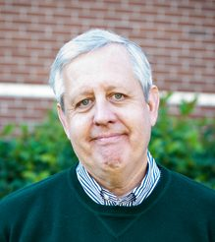

Internships
(Steve Neel & Lindsay Hudock )
- S. Neel (Mentor/Liaison advising network for athletes and COM majors)
- Human Communication & Communication & Conflict Internships (Orlando City Soccer, Orange County govt. Enterprise Holdings, Limbitless Solutions, Make A Wish, Siemens, Golden Key International Honor Society, Universal Studios etc.
- Intern Activities: social media, Marketing, Salles Human Resources, Event Planning, Customer Relations, research in marketing
- L. Huddock - Ad/PR Internships (Curley & Pynn, UCF, Darden, Evok, Seminole county public schools, etc.
- Intern Activities: Account services, copy writing & editing, event planning public affairs, social media
- For Ad/PR Internship opportunities you can visit the following site
https://quotesucf.com/

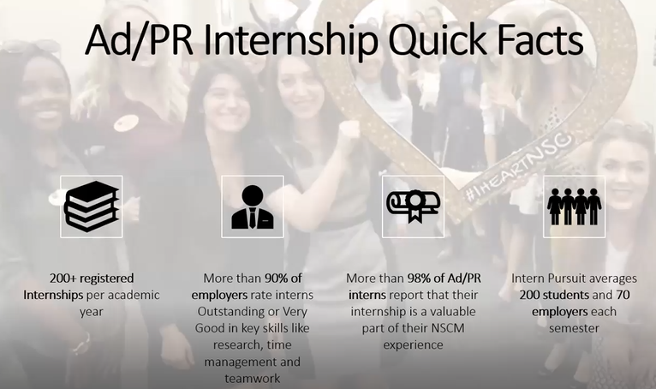

- Personal Fun/Fun Fact

Steve Neel -
- I played a round of golf with Don Henley of the Eagles at the golf course where the movie Caddy Shack was filmed
Lindsay Hudock -
- My maiden name is Giberti. I'm a descendent of a famous artist from the early Italian renaissance, Lorenzo Ghiberti. He's best known for creating the bronze doors of the Baptistery in Florence that Michelangelo would call the Gates of Paradise. He won the commission for the doors in a competition where he was a come-from-behind underdog. Everyone expected the commission to go to an already famous renaissance artist names Fillipo Brunelleschi. He had designed the dome of the Florence Cathedral, a feat of engineering that had not been accomplished since antiquity. He's now recognized as the first modern engineer and was the first person in the western world to receive a patent. It shocked the art community when he lost the commission to Ghiberti. So apparently, I come from a long line of underdogs.

Rob Lauzon (Post-Doc)
    - (Winter Park Sunshine Project) This past summer, I took over the Winter Park Sunshine Project as Nicholson’s first Postdoctoral Scholar. Since joining, we have taken over the project from Rick Brunson and trained Chelsea Velez, an MA student in the Nicholson School, on scraping data for keeping the site updated. Additionally, we have taken students from Mass Media Research Methods on a research journey and all students are currently listed as co-investigators on a mixed methods research project. Looking forward, we are hoping to have students in my spring section of Public Communication Campaigns take the data we have collected this semester and put together a campaign to promote Winterparksunshine.org. In the rap fandom wiki, I am listed in the first person to create a text battle message board for text-based battle rap. I created this forum back in 1998.
VI. ASSISTANT DIRECTORS REPORT and OLD BUSINESS (Deanna)
Goals for the Year - New Dean for College of Science asked each director to come up
with 3 goals for the year.
- Promoting ourselves and our excellent work, Website more user friendly
- Curriculum alignment, Communication for the professions (new course)
- Partnerships
On Campus Presence
Perception that we are not on campus, Deanna asking what days you are on campus.
Illustrate that we are on campus. Clarify to people are observing that our faculty are coming to campus/virtual
- Rufus – I am going to support what you’re doing, but going to voice in some ways its already articulated on my syllabi that same thing being asked from us
- J. Sandoval - faculty have no obligation to be on campus for anything except “scheduled activities” (i.e. classes, in person office hours, required meetings). Your friendly union reminder :)
- J. McCafferty - No place more depressing on earth than the DTC, students and faculty do not like it (A.Parrish) working on a survey)
- This is a school wide request not just NSCM.
- Main Campus CO-SPACE RM 218 are being co-shared.
- There is a culture of

Vacci-Knighted T-Shirts available CMB 168 (Maria Pichardo)

Coffee anyone?
Keurig/or Coffee system
NSCM “Big Picture”
- Doug Blemker took a promotional job at Disney.
- Boyd Lindsley leaving after the spring semester 22 and will go on sabbatical until Fall 2023
- Interim – anything you’re interested in taking from Boyd leadership opportunities, please let Dr. Littlefield know. This can provide leadership skills and he would like to do Interim.
- Michelle Dusseau : Can Dr. Littlefield provide a compensation schedule for those duties since Boyd was/is paid at level 7 admin and not faculty.
- Jen Sandoval: I would recommend listing what you would need/want to see in an MOU if you took on additional duties.
- Rufus – “There is a culture of offering opportunities without pay” as If you want something for nothing the more that happens the harder it gets to get quality work that you have to compensate people for the more it happens to get people to work for nothing. If no compensation just means just another thing on their plate.
- Deanna – Staff turnover is a concern
- A. Miller – Interim positions compensation is very low.
- Other Reports
    - NSCM Academic Programs and Student Services (Nan)
- Deadline to request graduate assistant for the spring semester contact before 12/1/21
- 11/16/21 for curriculum proposals or revisions.

    - NSCM Graduate Studies (Tim)
- Today @ 2pm Zoom Research Opportunities in DTC to make DTC more palatable
    - NSCM Inclusive Culture (Jen)

- Kicked off NCSM very 1st qualifying exams for PHD candidates of our 3rd year students of our 1st cohort.
- Recruitment of graduate studies students PHD program
- Inclusive culture Update: elections for the members of the committee will be held in the Spring. Ensure we have representation from each of the schools’ programs.

    - Master’s Program (Bridget)
- Requesting to serve as temporary advisor for 1st year Grad students.
- Creation of MA Admissions Committee/Looking for Volunteers
- Meet 2x in January and for the final Deadline in March (2-year commitment)

    - Curricular Alignment and Assessment (Michael) nothing major

    - Ad/PR (Joan)
- Fall admissions is highest of caliber than past years
- Average GPA is up and quality of writing on essays is noticeably better.

    - Human Comm/CC (Harry)
- Can’t find anyone to explain why they have a separate program requirement for high impact. Trying to find other ways to meet the higher impact requirements. Trying to designate Research methods class as a high impact course to avoid the bottle neck affect.

    - GEP Program (Adam)
- Textbooks for public speaking – students to opt in for an eBook which saves on cost of student fees. Automated system has been resolved, need to know if teacher is not using a textbook.
- Starting in January 22, will have some meetings with SPC1608, 1603, 1603H for Curriculum alignment (public speaking)

    - SONA (Christine) no sync problem
- Qualtrics is working well (research option)
- Deadline to earn Communication participation for COM 1000, is 11/30.21
- Message from IRB -because of staffing issues/mandatory training anticipate review process may take more than 6 weeks.

    - Alumni and Student Ambassadors (Jami)
- Mentorship awards 150 pairs.
    - Forensics Team (Jonathan C. & Maddox, M.)
- October both sides went to multiple tournaments, Debate side went to 3 and had some winders, top speakers, break to our rounds, Top #3, Top #5. Speech Teams will be competing this weekend virtually (Nebraska), Debate will compete virtually in Ohio.
    - Faculty Senate (Adam)
- Senate passed resolution that faculty can testify in courts or use expertise without university administration.
- PeopleSoft is being replaced with Workday
- Results from the UCF Downtown Campus Satisfaction Survey (survey went out on 11/10/21) results will be shared on 12/8/21 with Ross, Dr. Littlefield, Adam and 4 other people. Results will be shared with faculty at next COM Meeting in January.
- Cartwright – DTC was not his brainchild I feel he would like to fix that please take the time to answer the survey.

    - UFF (Jen)
- UCF Strongest articles of academic freedom
- Bargaining is still happening, 2.5% which will mean you won’t see anything until February 2022. Faculty presence is important in bargaining measure, would like to see Nicholson representation if possible.
- N-95 Masks available on main/DTC

    - Teaching Schedules (Michelle)
- Scheduling the 22/23 School year
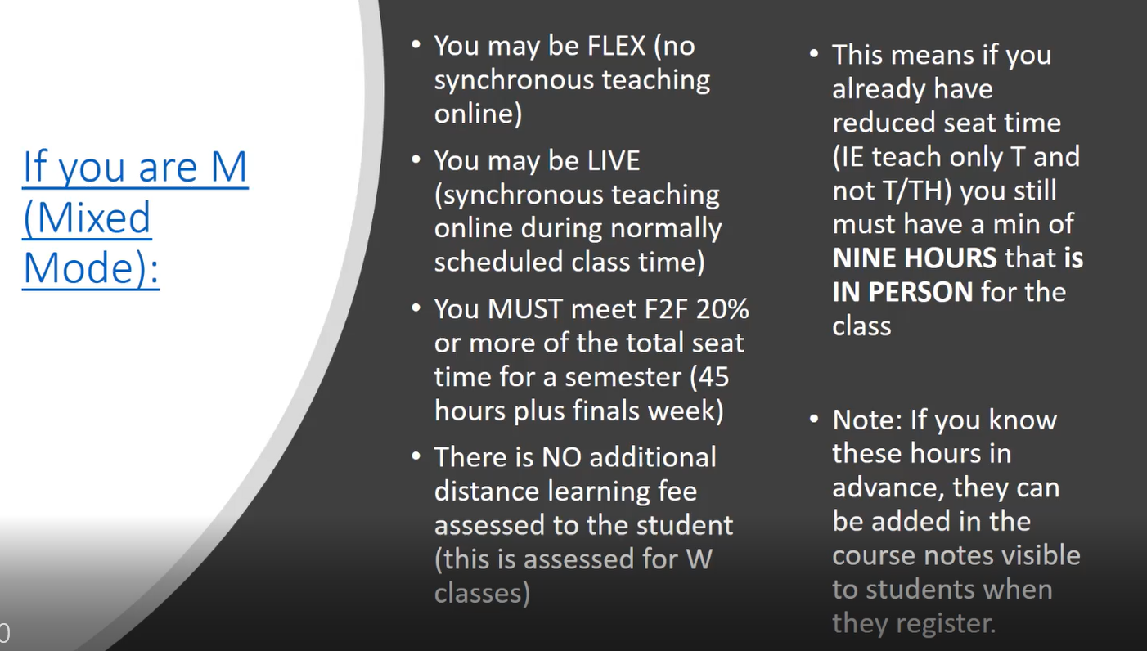
- FOR THE GOOD OF THE ORDER

ADJOURN – Motion Adam Parrish and 2nd, James McCafferty All in favor
Faculty Meeting: December 3, 2021 (10:00a.m.) End of year Celebration
(Location: Restaurant to be determined)

