Minutes of NSCM Undergraduate Curriculum Committee Meeting
November 5, 2021

Present: Zach Beckler, Taylor Howard, Will Kinnally (guest), Renata Kolodziej-Smith, Ann Miller (ex officio; chair), Andrea Scott, Kevin Smith, Kim Tuorto (ex officio), Harry Weger (guest)

The committee agreed initially to vote on course changes for Digital Media, Film, and Mass Media courses in batches because courses in each area were undertaken to address single sets of issues.

The committee unanimously approved changes to Digital Media courses that are all being made to streamline program curriculum flow and screen out students who make low grades in prerequisite courses. Course descriptions for a few courses were changed to match Kuali requirements. Changes were approved for the following courses:

DIG 2783
DIG 3024
DIG 3134C
DIG 3146
DIG 3174C
DIG 3175
DIG 3480
DIG 3525
DIG 3716C
DIG 3727C
DIG 3728C
DIG 3811
DIG 4104C
DIG 4172C
DIG 4294C
DIG 4295C
DIG 4324C
DIG 4503C
DIG 4595
DIG 4630
DIG 4633C
DIG 4639C
DIG 4713
DIG 4715C
DIG 4720C
DIG 4725C
DIG 4726C
DIG 4778C
DIG 4780C
DIG 4813

Final vote was 6/6 on the group of changes. Results of the poll are inserted below. Note that all totals are out of the six voting members.

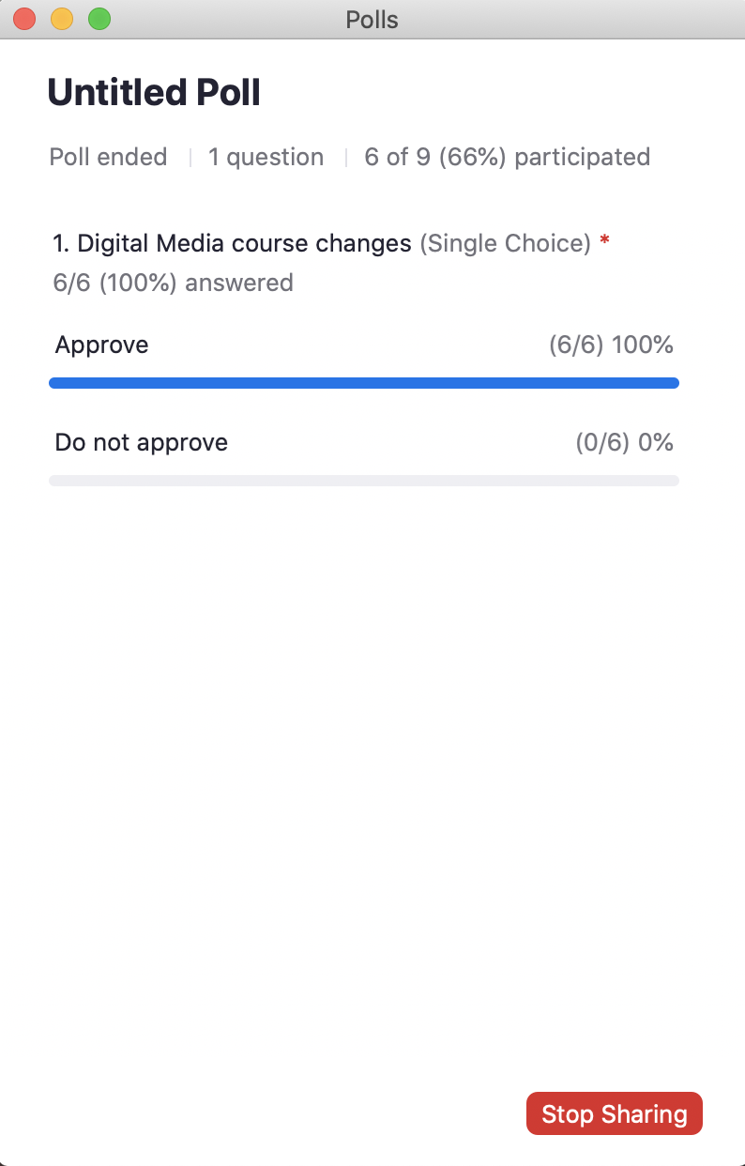
The committee unanimously approved changes to Film courses, all of which were proposed in order to address certain auditing issues. Changes were approved for the following courses:

FIL 2424
FIL 2481
FIL 2552
FIL 3036
FIL 3037
FIL 3051
FIL 3102
FIL 3115
FIL 3462C
FIL 3803C
FIL 4427C
FIL 4439C
FIL 4451 (pending receipt of syllabus)
FIL 4453
FIL 4472C
FIL 4486C
FIL 4535C
FIL 4536C
FIL 4566C
FIL 4602
FIL 4615C
FIL 4647
FIL 4876C

Final vote was 6/6 on the group of changes. Results of the poll are inserted below.

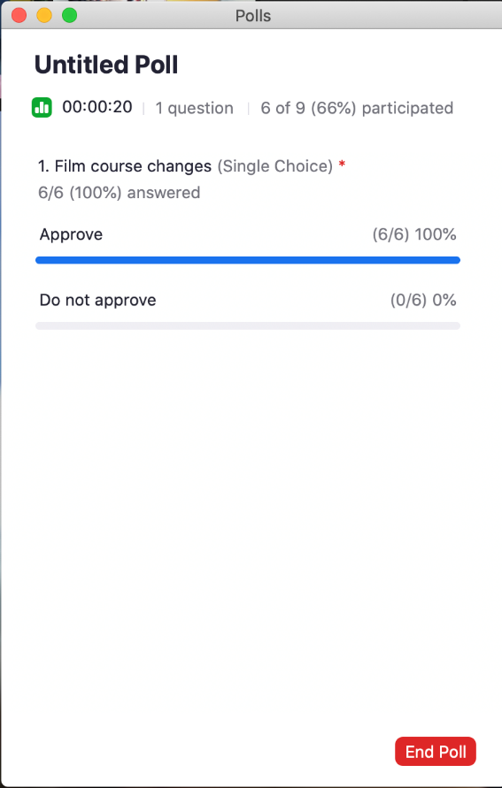

The committee unanimously approved changes to RTV and MPM courses, which were proposed in order to reflect the major name change from Radio/Television to Media Production and Management, and to remove material and supplies fees for courses which no longer require flash drives. Some adjustments to prerequisites were also made. Changes were approved for the following courses:

RTV 3531
RTV 3543C
RTV 3556C
RTV 3571C
RTV 3576C
RTV 3581C
RTV 3601C
RTV 4544
RTV 4561C
RTV 4591C
RTV 4700

Final vote was 6/6 on the group of changes. Results of the poll are inserted below.

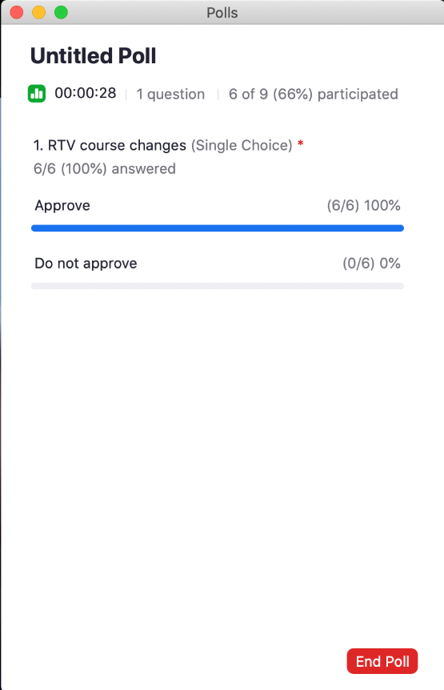

The committee unanimously approved changing COM 3311 to a high-impact designated course. The final vote was 6/6 on the change. Results of the poll are inserted below.

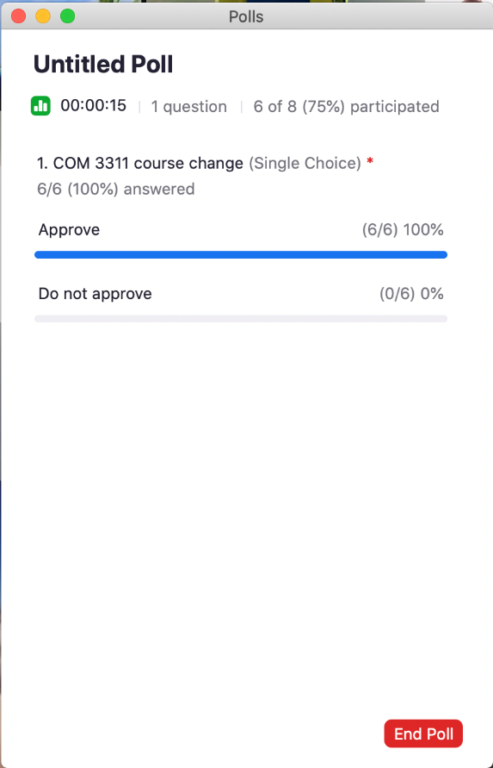

The committee unanimously approved changing the course description of COM 4014. The final vote was 6/6 on the change. Results of the poll are inserted below.

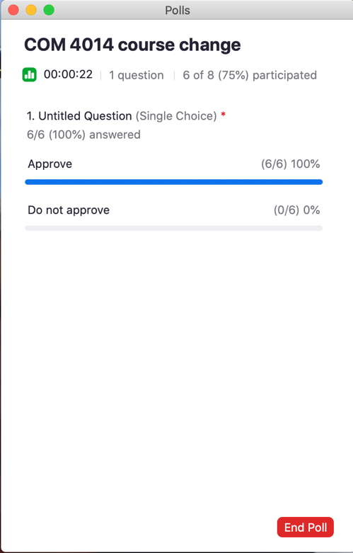

The committee approved tabling the vote on PUR 3463 and PUR 4XXX until the next meeting because Kuali submissions were incomplete. Results of the vote are inserted below. (This vote was unanticipated, so no poll had been created. Committee members voted in the Chat function of Zoom. Please ignore Ann Miller’s accidental vote. One of the six committee members did not vote, so the tally is 5/5.)

