Policy and Planning Committee Meeting Minutes 1.13.2021
12:00 PM

Present: Steve Collins, Matthew Mosher, Bridget Rubenking, Sally Hastings, Peter Smith, Ann Miller (chair), Robert Littlefield (guest)

- The committee first heard from Dr. Robert Littlefield who addressed questions sent to him about the background to the ELP policy and situation in depth. He also received questions from committee members.

- The committee was informed that minor changes in wording in the Instructor/Lecturer promotion document had been requested by the Dean of COS and had been incorporated and approved by the ad hoc I/L promotion committee chair. The committee voted to send the Instructor/Lecturer promotion document pending two minor changes by the ad hoc committee chair to faculty for a vote (5 yes; 0 no; 1 abstention). See vote results below.

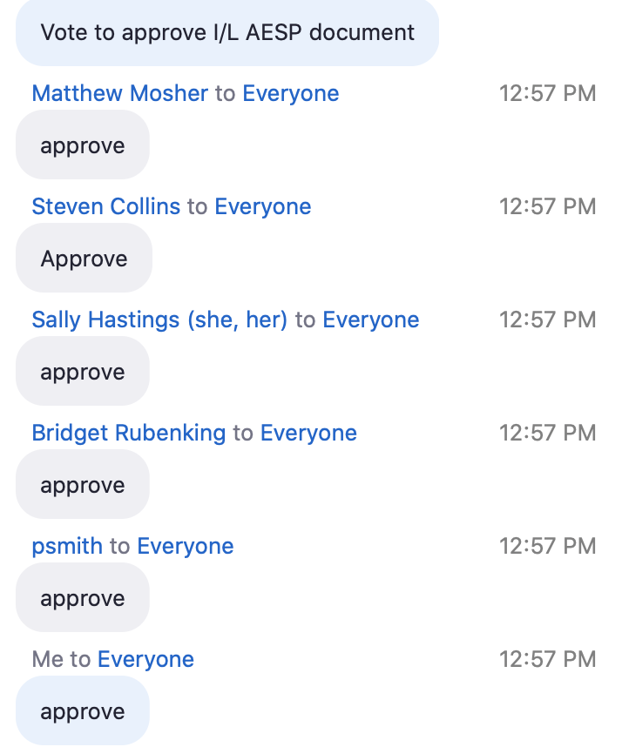

- The committee was informed that minor changes in wording in the Instructor/Lecturer AESP document had been requested by the Dean of COS and had been incorporated and approved by the ad hoc I/L AESP committee chair. The committee voted unanimously to send the Instructor/Lecturer AESP document to faculty for a vote.

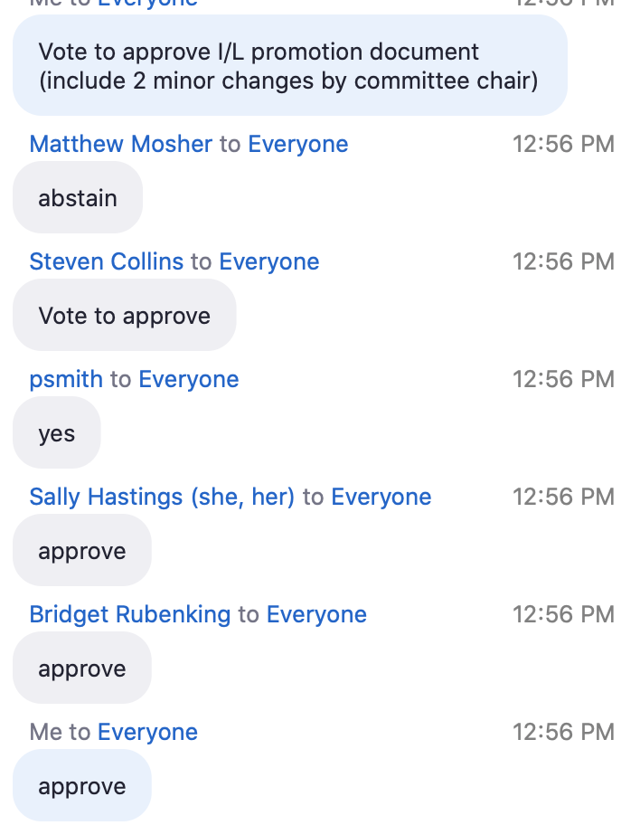

- Action steps:

- Committee members are to take information from Robert Littlefield back to their units for feedback prior to the next committee meeting so they can report faculty opinion in each program area to the committee.
- Members were also informed that as with the two documents on which the committee voted in this meeting, minor changes in wording have been requested by the Dean of COS to the P & T guidelines and have subsequently been incorporated. However, one substantive change remains to be made. That change has been passed back to the relevant ad hoc sub-committee. It is anticipated that they will have given input by the next Policy and Planning Committee meeting.

