Sedona Faculty Training Manual

Logging In
It is recommended that you access Sedona using the Google Chrome web browser. Other browsers tend to cause issues with Sedona.

Go to www.sedonaweb.com. Check to see that ‘Member’ is selected in the drop-down menu.
Enter username and password. If you forget your password, you can have it emailed you your UCF email address by selecting the I forgot my ID/password link. (Note: Please check your junk email box for an email from @sedonaweb if you do not receive the email within a few minutes of making the request)
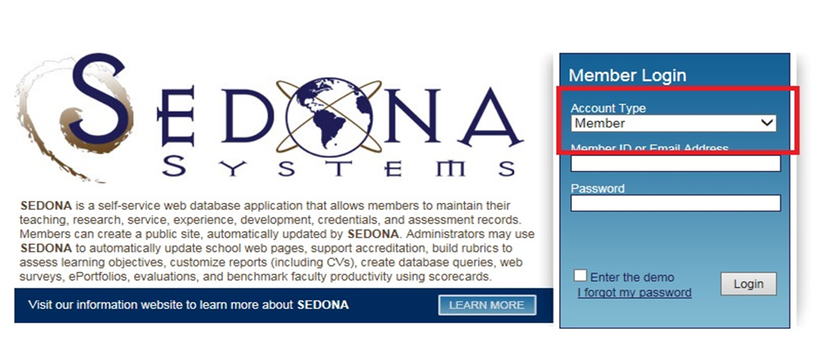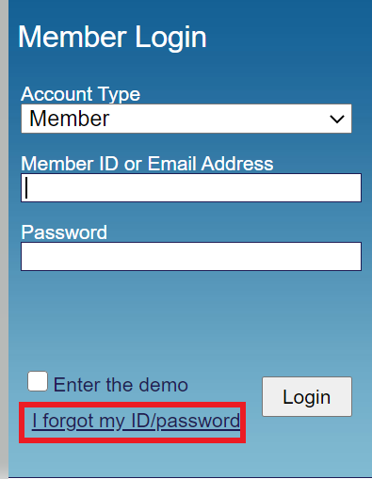

Steps for Submitting End-of-Year Reports

#1 Adding Activities
During the reporting period, from May 8 to May 7, add new activities into Sedona as they occur. This includes new publications, exhibits, game development, films, research supervision, service within and outside of UCF, etc. Adding these activities throughout the year will make submitting reports at the end of the year quick and easy. For more details on how to enter activities into Sedona see the Entering Activities section below.

#2 Completing the Faculty Annual Report
Access to your COS Report is located under Templates and is titled ‘COS Faculty Annual Report’. After entering activities by following the information located in the Adding Activities above, when you are ready to submit your reports, start by pulling up your COS report in Sedona. Review the information in the report to ensure that all relevant activities are included and accurate. The teaching schedule is entered by NSCM staff using the course registration profile if you find any errors with your teaching schedule please notify Kim Tuorto, kim.tuorto@ucf.edu. All other information can be edited by you within your member profile. To include a personal statement at the end of the COS Report, please fill out the Personal Statement field under Narratives in your ‘Profile’. Once you have verified that the COS report is complete and accurate download and save the report as a PDF file and email this file to Kim Tuorto, kim.tuorto@ucf.edu.

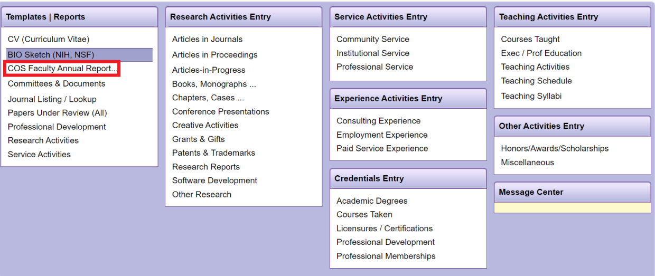

#3 Annual Evaluation Standards & Procedures Report (Self-Evaluation)
To begin the AESP, go to the ‘Self-Evaluation’ link on your Sedona homepage and select your designated self-evaluations, details located in #3a to #3c below.

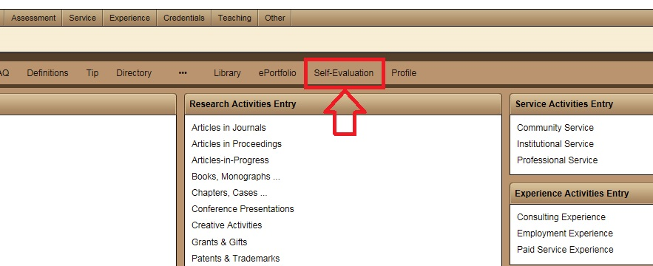

Things to Remember:
- If you need to exit the AESP at any time, your progress will be saved automatically.
- Each section in the AESP pulls information entered in the COS report into the corresponding AESP section.

Instructions for Tenured and Tenure-Earning Faculty and Legacy NSC Non-Tenured Faculty ONLY:
Instructions are provided as to how many criteria must be fulfilled to achieve the levels of Satisfactory, Above Satisfactory or Outstanding in each section. Based on these activities and other information, check off all the criteria which you have fulfilled. For criteria which may be counted more than once, please specify the number of times it is to be counted and explanation of activities in the “Other” or “Narrative Textbox” box at the end of the section.

If you would like to include a summary, this can be done at the end of the AESP. You can attach up to one document to your AESP. This can be done by clicking the ‘Attach’ button in the upper right-hand corner. (Please note, that Sedona will only allow you to attach one document. Therefore, if you would like to attach several documents, you must combine them before attaching them into Sedona.)

After your additional documentation has been attached, click the green ‘Submit’ button in the upper right-hand corner to complete your submission.

Instructions for Legacy SVAD and FIEA Non-Tenured Faculty ONLY:
After reviewing the information in your AESP report proceed to the next section.

Note for tenured/tenure-track faculty: Please refer to the AESP document in the Sedona Library to find the full listing of examples, stipulations, and criteria for checklist items with the phrase ‘please see attached’ at the end.

#3a Tenured and Tenure-Earning Faculty Members from all program areas
Select the T/TE AESP ALL [Effective 2022-2023] Self-Evaluation

# 3b Legacy NSC Non-Tenure Track Annual Evaluation Standards & Procedures Report (Self-Evaluation)
Select the Legacy NSC Non-Tenure Track AESP.

#3c. Legacy SVAD & FIEA Non-Tenure Track Annual Evaluation Standards & Procedures Report
Select the Legacy SVAD Faculty or FIEA Faculty AESP.

#4 Submitting Your CV
Your up-to-date CV can be submitted to Kim Tuorto, kim.tuorto@ucf.edu. You may use either your own CV or the one provided in Sedona. The template in Sedona will include all your past academic and work experience, teaching, research, and service activities that have been entered into Sedona. The Sedona CV template can be saved as a Word document or PDF.

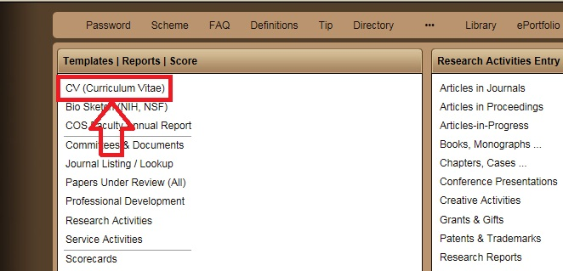

#5 Celebrate!
You’ve finished another year’s worth of reports!

See below for additional information on using Sedona.
Profile

A link to your member ‘Profile’ is on the right-hand side of the upper task bar or in the middle of the page on the lower task bar. Here you can update your bio, contact information, narratives, expertise, and references.

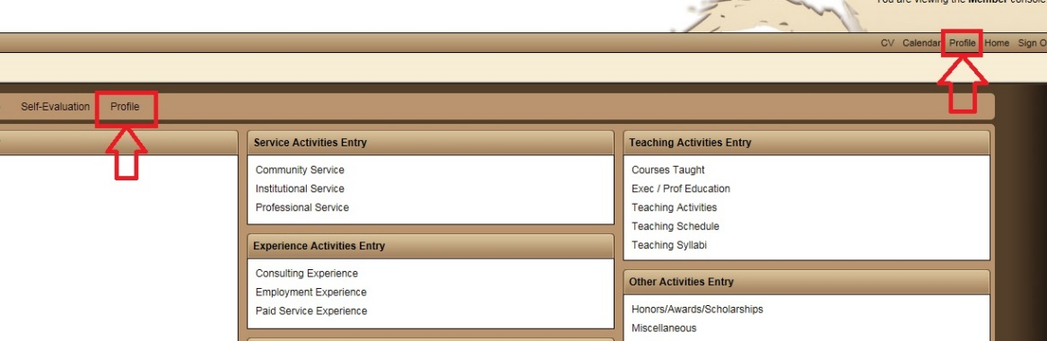
Narratives

Some elements of the reports in Sedona will require you to fill out a narrative. These can be found under your ‘Profile’ in the tab labeled ‘Narratives’. Then fill out the appropriate narratives as directed in the relevant report. Please update these each academic year and remove them if they are no longer relevant.

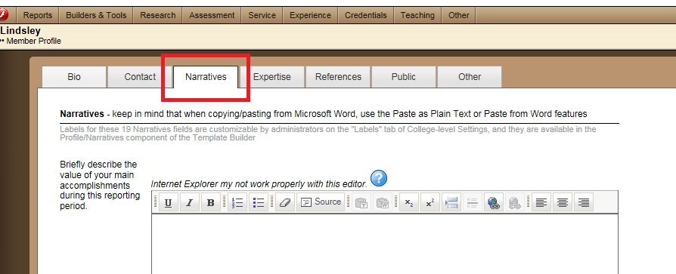

Entering Activities

- Teaching
To enter a new Teaching activity, click on ‘Teaching Activities’ under ‘Teaching Activities Entry’ section on the Sedona homepage. This page will list all past teaching activities. Click on the green ‘Add’ button in the upper right-hand corner. Fill out as much information about the activity as you can and click the green ‘Save’ button in the upper right-hand corner. You should now be able to see this activity listed in ‘Teaching Activities’.
- Course Development: Items related to course development including Course Redesign, New Course Content and/or Delivery, Laboratory Development, and Special Course Requirements are entered here.
- Mentoring Activities: All student mentoring activities should be included as teaching activities including supervision of student research, internships, and students assigned for advisement.
- Graduation Attendance: This will be listed under Institutional Service

- Research and Creative
To enter a new Research activity, choose the research category in the ‘Research Activities Entry’ section on the Sedona homepage into which the activity best fits. Once the category is selected, all past activities in that category will be displayed. Click on the green ‘Add’ button in the upper right-hand corner. Fill out as much information about the activity as you can and click the green ‘Save’ button in the upper right-hand corner. You should now be able to see this activity listed in that category.
- Citations of Work: Citations of work are listed under ‘Other Research’ as ‘Citation of Work in Other Publications’ This entry provides an area to put a link to a Google Scholar or other page or an area to put a description of the number of citations. Please only provide the number of citations generated in the last year.
- Creative Activities: Exhibitions, Festival Screenings, Film Development, Game Developments, Other Creative Activities and Shows may be entered here. You may also add the status (Completed, Produced, Directed, Published), length if applicable, and note if the activity was Juried, Invited or Work-in Progress.
- Journals: Journals must be verified before they are added to Sedona’s journal list. So, if a NSCM faculty member has not published in a particular journal before, it will not appear in the dropdown of journal titles. If you are entering an article in a journal not on the Sedona list, submit a petition to have the journal added to the list. NSCM staff will then verify and add the journal. If you are entering an article in a journal which you find is incorrectly listed on Sedona’s list, submit a petition which correctly lists the journal and email Kim Tuorto kim.tuorto@ucf.edu, notifying her of this to have the listing fixed.

- Service
To enter a new Service activity, choose from Community, Institutional or Professional Service. Once the category is selected, all past activities in that category will be displayed. Click on the green ‘Add’ button in the upper right-hand corner. Fill out as much information about the activity as you can and click the green ‘Save’ button in the upper right-hand corner. You should now be able to see this activity listed in that category.
- Community Service: Please include all community service regardless of its relevance to your field. This information is helpful to NSCM staff when compiling reports on the school.
- Institutional Service: The dropdown for this section includes activities such as ‘Mentoring Activities’ and ‘Thesis/Dissertation – Chair or Co-Chair’ but these activities should actually be included in the teaching section. Graduation Attendance is listed here.
- Professional Service: The dropdown for this section includes activities such as Reviewer, Officer, Juror, Reviewer, and Chair.

Help and FAQ
If you have trouble with any of the sections on Sedona, video tutorials are available under the Help link. Also Frequently Asked Questions can be found at the FAQ link on the lower task bar.
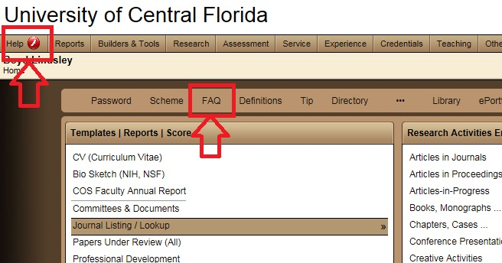

Contact
If you have any additional questions about Sedona, please contact one of the following:

Shameika Daye – sdaye@ucf.edu, 407-823-5231
Kim Tuorto – kim.tuorto@ucf.edu, 407-823-2882

